**All documentation on the Smart plug to Webhook to PIR sensor**

**User Manual**

**General**

Before starting to build the project make sure that the user understands the correct orientation of the devices used for the project. User needs to be familiar with the layout of the materials used to be able to complete the assembly successfully, if the user mistakenly plugs the wires incorrectly it may cause failure of both devices. Please exercise caution before assembly. Images will be provided to help the user throughout the assembly process.

**Assembly**

The set up of the raspberry pi is very simple. The require materials are as follows:

3 female to female jumper cables

1 raspberry-pi

1 PIR-sensor

1 micro-usb cable

1 power supply

Once all the parts are acquired do not plug in the power immediately. We will need to make sure that we follow the schematic above one cable at a time. Make sure to look at the bottom of the PIR sensor to see which labels are on the different pins. Start by connecting the Vcc to the top most pin on the right of the raspberrypi. Follow that with connecting the ground connection on the PIR with the 3rd pin down on the top right of the pi. The last connection will be connecting the middle pin of the PIR sensor with pi and that connection will be the 6th pin down from the left side. Once all this is set up you can then power the pi on.

**Schematic of raspberry pI connected to pIr sensor**

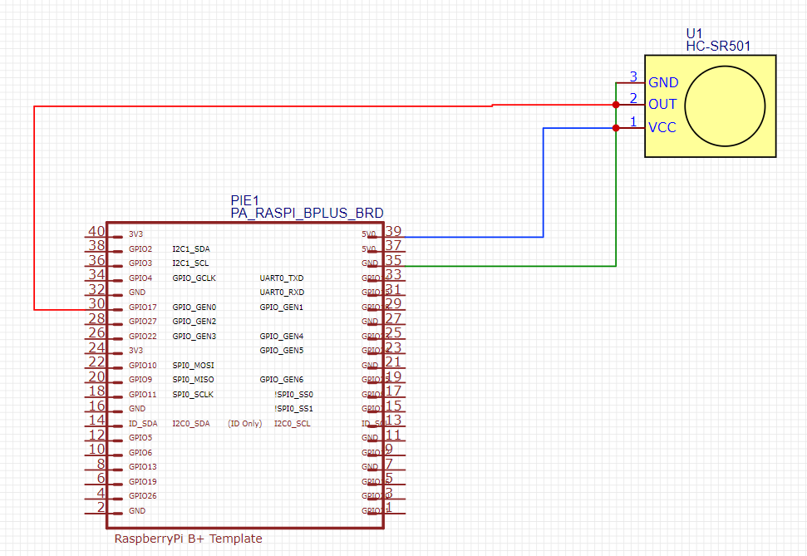

**Using webhook to link kasa and allow raspberry pi to receive info**

Using third party software create a webhook to trigger the smart plug. App of the smart plug is KASA so we connect the KASA app to our webhook. Webhook must indicate what the action will cause and will sync to the program that the smart plug is then connected too to give the command. Then we copy the key that is given to us by this third party software to put into our code to run it through the webhook.

**To create start up on boot function (OPTIONAL)**

Start by typing sudo nano /home/pi/.bashrc

At bottom of bashrc file type sudo python3 /home/pi/ifttt/iftttpir.py

Function should clear the cmd prompt to start posting if motion is detected after restart.

**Real life model of the raspberry pi and PIR motion sensor**

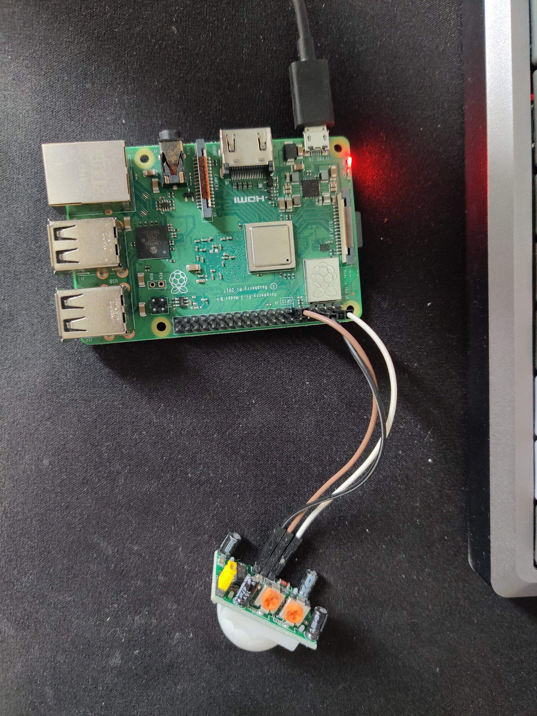

**Smart plug used is TPLink Kasa smartplug HS103**

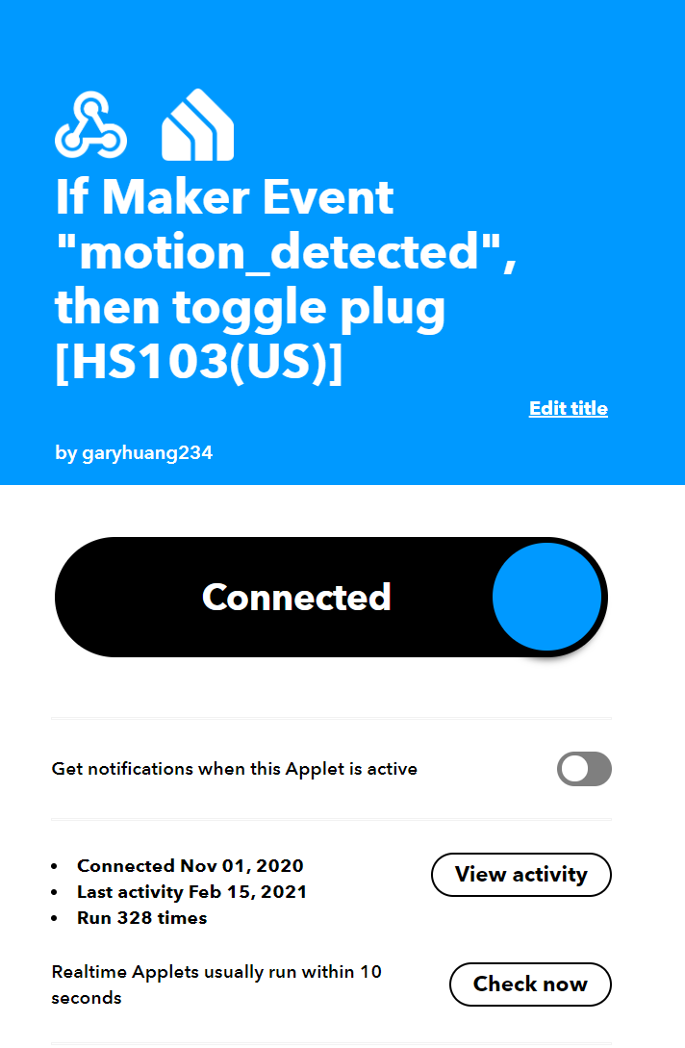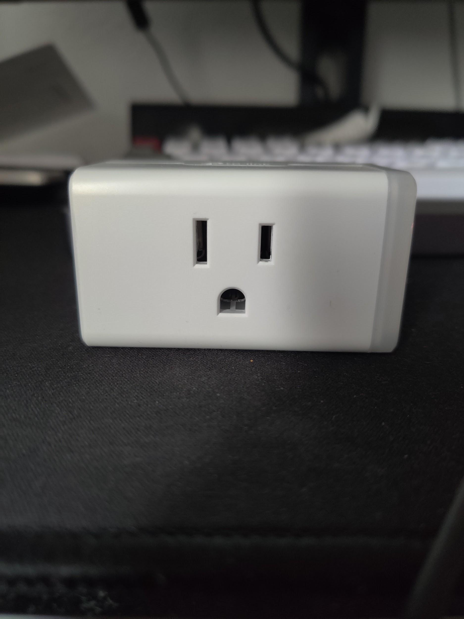

**Smart Plug is lit up when motion is detected**

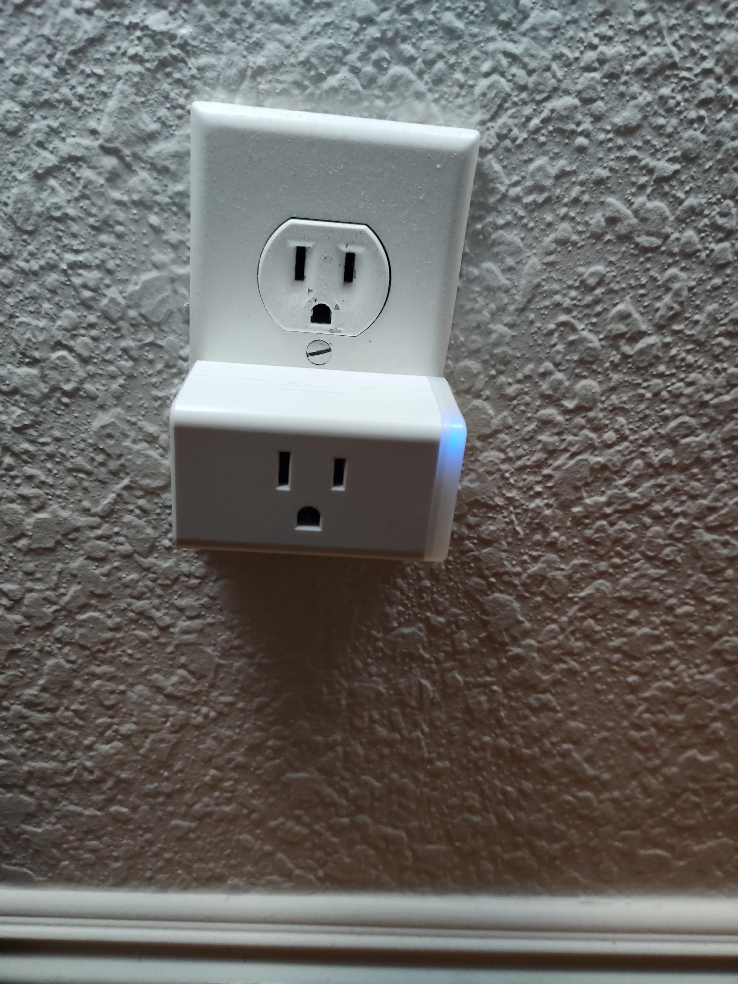

**When motion is detected (emmulates leaving) so plug turns off.**

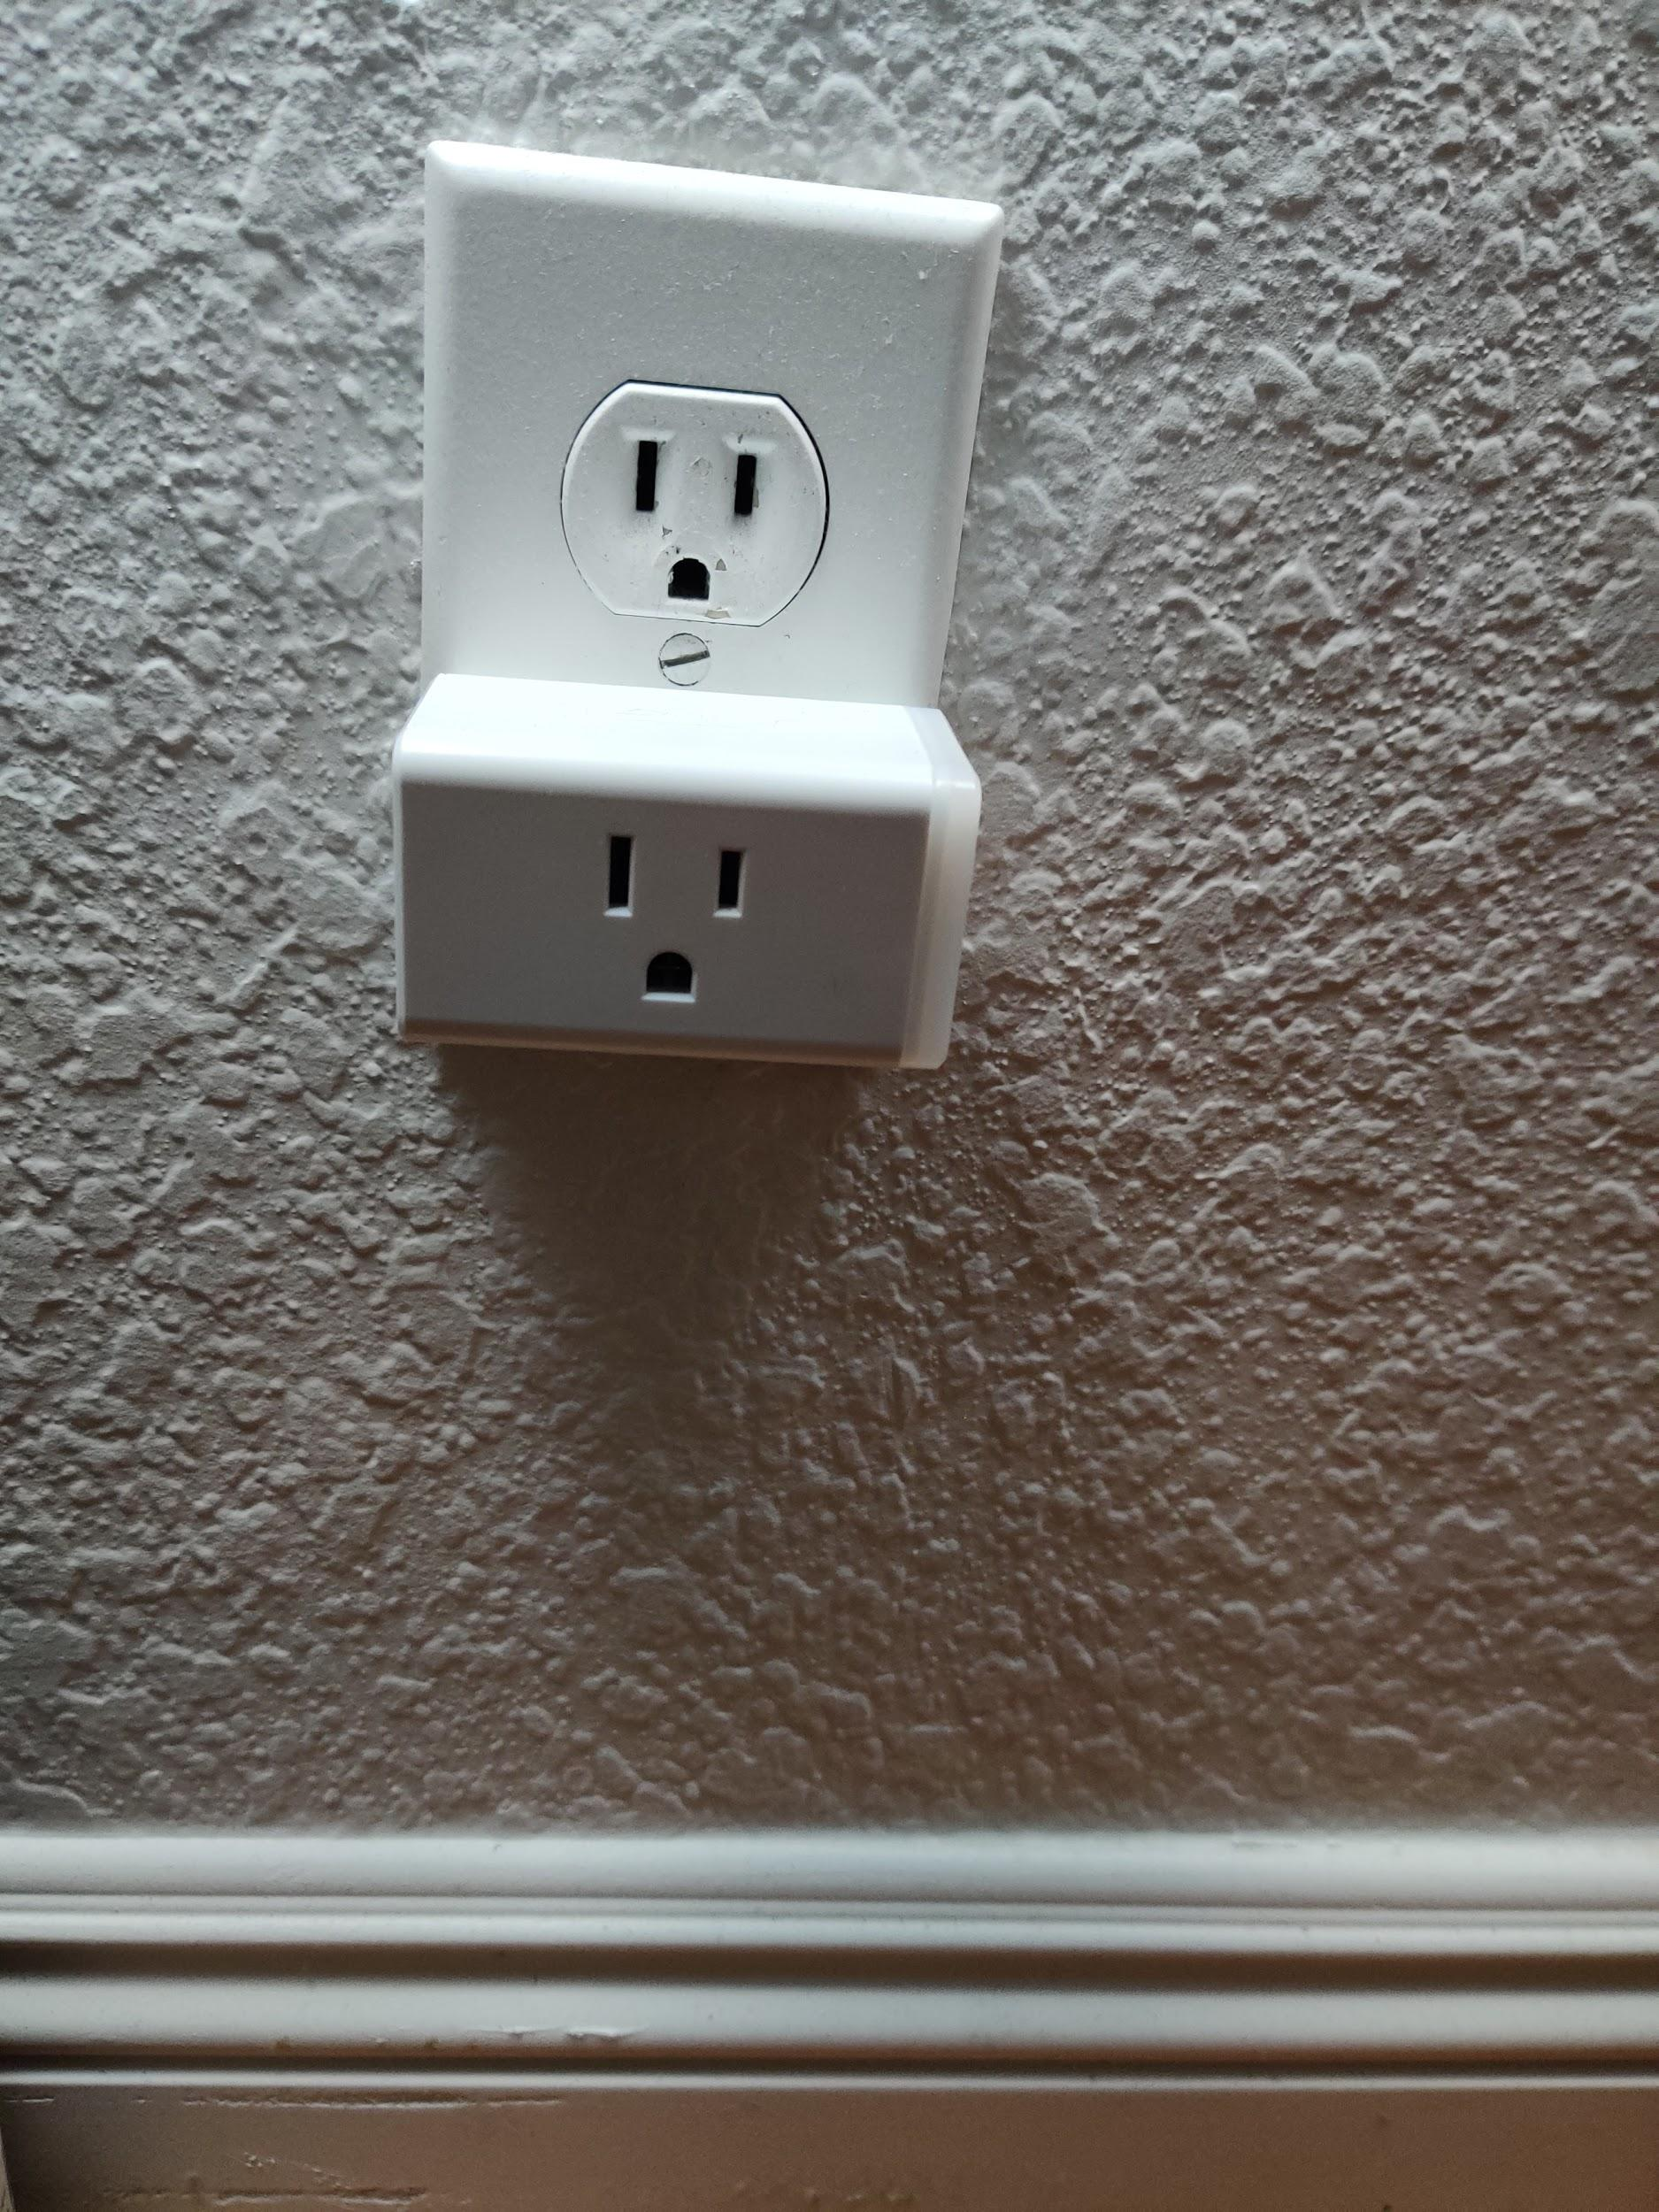

**The readout on the raspberry pi of when a motion is detected**

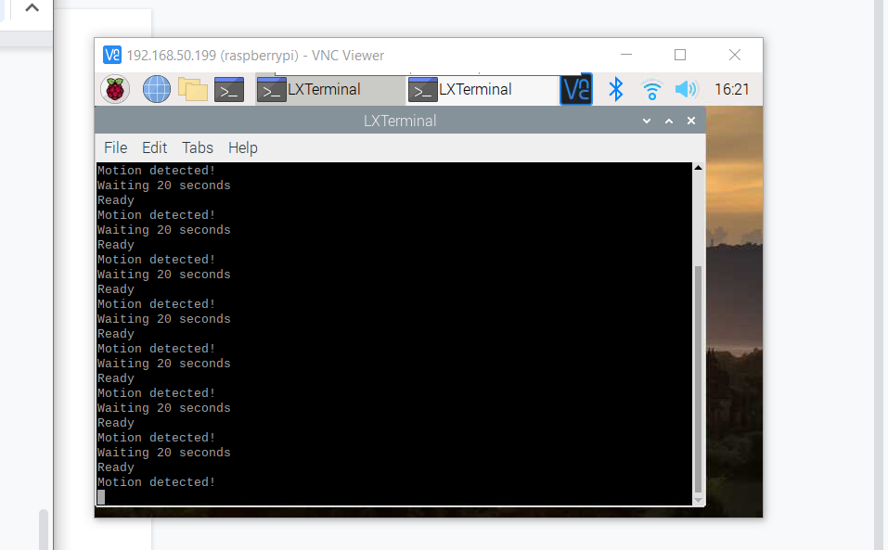

Presentation with embedded videos

IEEE paper